840729451396

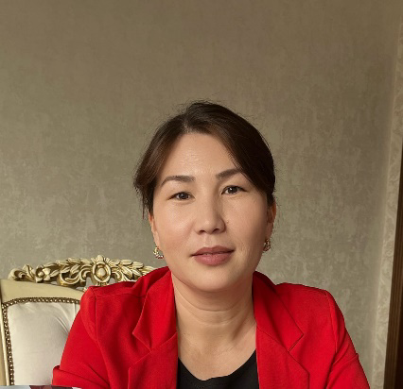

**КЕНЖАБЕКОВА Бахтыгуль Абдумаликовна,**

**С.Нұрмағамбетов атындағы №72 жалпы орта білім беретін мектебінің ағылшын тілі пәні мұғалімі.**

**Шымкент қаласы**

**MASKS ON STAGE**

|  |  |
| --- | --- |
| **Learning objectives(s) that this lesson is contributing to:** | 10.4.2 - understand specific information and detail in extended texts on a range of familiar general and curricular topics, and some unfamiliar topics;  10.3.4 - evaluate and comment on the views of others in a growing variety of talk contexts on a growing range of general and curricular topics;  10.3.7 - use appropriate subject-specific vocabulary and syntax to talk about a range of general and curricular topics; |
| **Lesson objectives:** | learn the vocabulary and text  answer the questions, identify types ofmasks  make a presentation |

**Plan:**

|  |  |  |  |  |
| --- | --- | --- | --- | --- |
| **Part of the lesson/Time** | **Teacher’s activity** | **Student’s activity** | **Assessment** | **Resources** |
| **Beginning of the lesson**  **Pre-learning**  **«Brainstorming» method**  **10 min.** | The teacher greets the class.  The teacher divides the class into two groups.  I-group Mask  II-Stage  (After the lesson the teacher will identify which group was the best)  Revision of previous lessons materials with the help of the teacher.  **Differentiation: “verbal support”**  T asks different questions connected with the theme and tries to help Ss to give the correct answer. T asks leading questions to clarify the theme to the Ss who needs T support.  Ss give their possible answers. After that T introduces the aim and theme of the lesson. | Questions:  1. Why do people make masks?  2 What kind of masks do you like?  3 Do you think it’s easy to become a good actor? Why/Why not?  Aim: Revise the previous lessons material.  Efficiency: Ss refresh their mind before starting new theme.  I-group Mask  Theatre mask against the background Stock Photo by ©Elnur_ 5612785  II-Stage  Stagestruck: Curtain Up on Stage 3 | **Descriptor:**  -answer the 1st-question  - answer the 2 nd-question.  Total: 2point  Encourage Ss who answer the questions | Whiteboard  Card  Students Book  U6t  https://wordwall.net/ru/resource/52956916 |
| **Middle of the lesson**  **5min.** | **Working with Wordwall platform**  Ask Ss to read the statements 1-8. Give Ss time to read the text and mark each statement according to what they read in the text.  **Aim:** to read for specific information  **Efficiency:** to develop Ss reading skills  **Play the video for Ss**. | **Exercise 1** Mark the sentences T or F. | -choose the right answer  1 point | Whiteboard  Students Book  Poster  <https://wordwall.net/ru/resource/52956677>  <https://youtu.be/5eTKFEr3MFs> |
| **6 min.** | Explain the task and give Ss time to choose the correct response for each item.  **Aim:** to consolidate situational language | **Exercise 2** choose the correct response | **Descriptor:**  -Choose the right answer  1point | Whiteboard  Students Book |
| **Individual work**  **9 min.** | Explain the task. Ss complete the task.  **Aim:**to practice vocabulary; determiners, pronouns and quantifiers  **Efficiency:** to develop Ss writing skills  **Differentiation: practice** method is used to assess Ss writing | Exercise 3 | **Descriptor:**  -Choose the right answers  2 points | Whiteboard  Students Book  Poster  https://wordwall.net/ru/resource/52957225 |
| **5 min.** | Ask Ss to watch the video. Play the recording.  **Aim:** to listen and watch for specific information, play out the scene  **Efficiency:**  Develop their listening and speaking skills  **Differentiation: practice** method is used to assess Ss speaking | Ss watch and understand the meaning of the video.Then the students will have to play the roles of these same characters | **Descriptor:**  Listen  watch  speak  - 2 points | Whiteboard Students Book  Poster.  CD 2.16 |
| **Speaking task**  **5 min.** | Explain the task. Give Ss time to paint and tell about types of masks  **Aim:** improve speaking skills  **Differentiation:** digital resources | Ss read,draw,retell | Ss evaluate each other and encourage classmate with phrases like:  Well done! Brilliant! Good job! I like it! | Whiteboard  Students Book |
| **End of the lesson.**  **Reflection**  **5 min.** | The One-Minute Papers method was used as a reflection. It provides the opportunity to the students to provide a quick reflection on what they learned by responding to questions.  **Blob classroom**    Home task : ex 6 p.88 Write an article about a famous actor or actress from your country (120-180 words) | Ss answer the questions like : What is the most important issue discussed today?  What did you find difficult to comprehend?  What are some questions you would like to explore further?  **Aim:** To know how many Ss got the theme.  **Efficiency:** To make appropriate modifications that would enhance students’ learning engagement and performance  **Differentiation:** **«Conclusion»** method is used to finish the lesson.  Ss note down | Ss evaluate each other and encourage classmate with phrases like:  Well done! Brilliant! Good job! I like it! | Whiteboard  Students Book  Blob card  Stickers |